**PROJECT TOPIC: Text to Image Generation Using Generative Adversarial Networks and RNN**

**Group No.:259**

**Project Group Members:**

1. BHAGYODAYA VARSHNEY (D-28/2115000284)

**2.** SHRAY GUPTA(C- 55/2115000968)

**3.** VANSH VERMA (K-59/2115001089)

**4.** YASH PATEL (D-71/2115001156)

**Project Supervisor:** Mrs. SABITA ARORA, Assistant Professor

**About the Project:** The Text to Image/Video Generator is our fourth-year major project that uses natural language processing and computer vision to convert text descriptions into high-quality images and videos. By employing generative adversarial networks (GANs) and recurrent neural networks (RNNs), it enhances output realism and coherence. Aimed at democratizing creativity in fields like digital content creation and education, the project features an intuitive user interface and focuses on efficiency, scalability, and real-time generation, incorporating user feedback for ongoing improvement.

**Motivation:** The Text to Image/Video Generator project represents a significant advancement in AI, transforming text into visual content and democratizing creativity for all users. Its applications in education, marketing, and entertainment enhance communication and engagement. By promoting innovation in AI, the project also offers insights into machine understanding of language and imagery, with potential societal benefits for the future.

**Innovation**:

• **Multi-Modal Input Support:** Accepts various input forms (detailed descriptions, keywords) for flexible user interaction.

• **Contextual Style Adaptation:** Enables users to specify artistic styles (e.g., realism, abstract) for personalized outputs.

• **Dynamic Scene Creation:** Generates short videos that depict motion or transitions based on text, enhancing storytelling.

• **Interactive Feedback Loop:** Allows users to refine inputs based on initial outputs, improving relevance and quality.

• **Ethical Content Filtering:** Ensures generated content adheres to community guidelines, preventing harmful or inappropriate material.

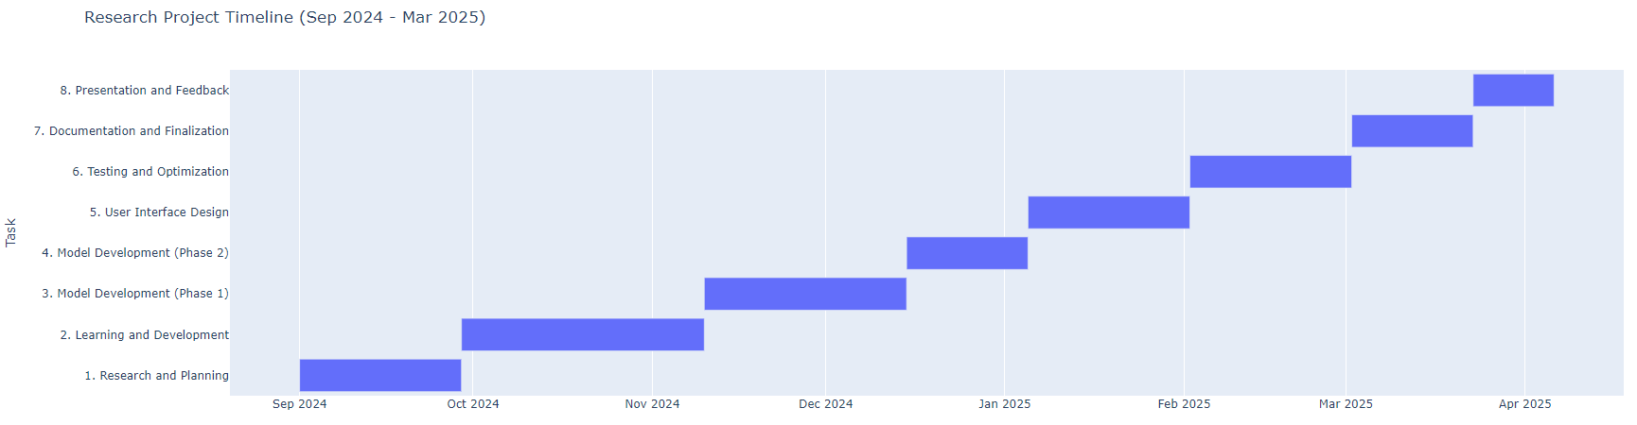**Project Planning :**

**Hardware Requirements:**

1. **Computer System:**
   * **Processor:** Intel i5 or AMD Ryzen 5 (or higher)
   * **RAM:** Minimum 16 GB (32 GB recommended)
   * **GPU:** NVIDIA GeForce GTX 1060 (or higher)
   * **Storage:** SSD (minimum 512 GB) + additional HDD space
2. **External Devices:**
   * **Monitor:** Dual monitors for multitasking

**Software Requirements:**

1. **Development Environment:**
   * **Operating System:** Windows, Linux, or macOS
   * **IDE/Text Editor:** Visual Studio Code, PyCharm, or Jupyter Notebook
2. **Programming Languages:**
   * **Python:** For machine learning and deep learning implementation
3. **Libraries and Frameworks:**
   * **Deep Learning:** TensorFlow or PyTorch
   * **NLP:** NLTK or SpaCy
   * **Image Processing:** OpenCV or PIL
4. **Version Control:**
   * **Git:** For version control and collaboration
5. **Data Management:**
   * **Documentation:** Jupyter Notebooks
6. **Deployment Tools:**
   * **Containerization:** Docker

**Signature of Project Supervisor: _____________________**